MySQL

Basic Commands: -

>> show databases; ----to show the databases

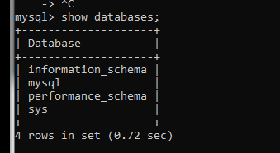

>>use databasename; ----to select or use any database.

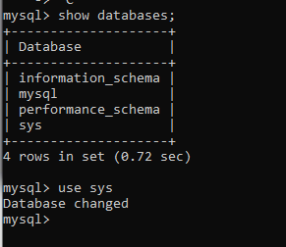

>>show tables; ---to see all the tables in that database.

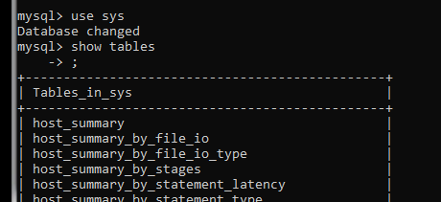

>> create database <database name>; -- to create any database.

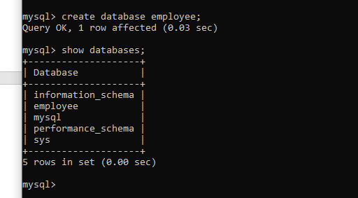

>>drop database <database name>; ----to remove any database.

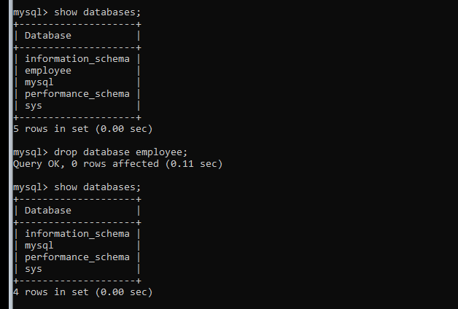

>>create table employee(empid int(6),empname varchar(50), salary float(8,2)); ---to create table and it’s header.

>>describe <table name >; ---use to describe the table.

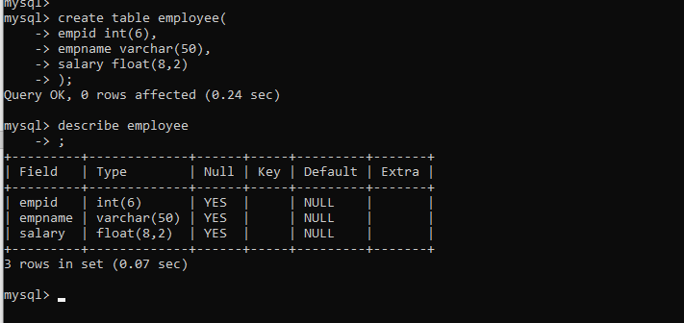

mysql> insert into employee(empid,empname,empsalary) values (10,'Suman',20000.50); ----insert data into table. Need to maintain the order wise column value.

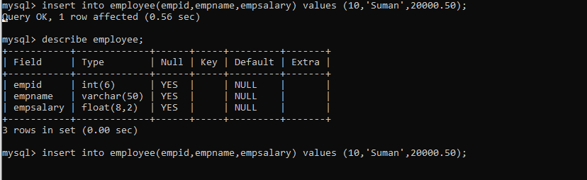

>>mysql> select \* from employee; ---is also use to show the table. And its data.

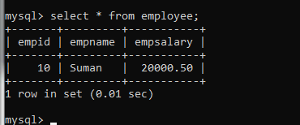

Update date into Table:

Now we have to increase everyone salary by 500 rupees.

mysql> update employee set empsalary=empsalary+500;

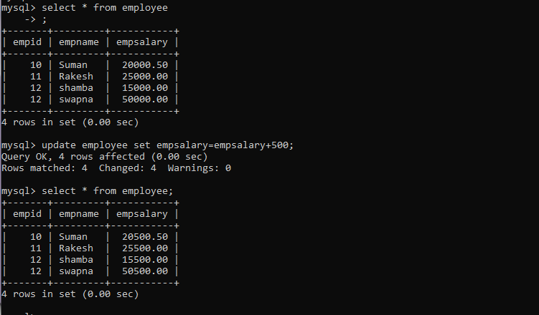

Update salary conditionally: -

mysql> update employee set empsalary=empsalary+500 where salary<20000;  
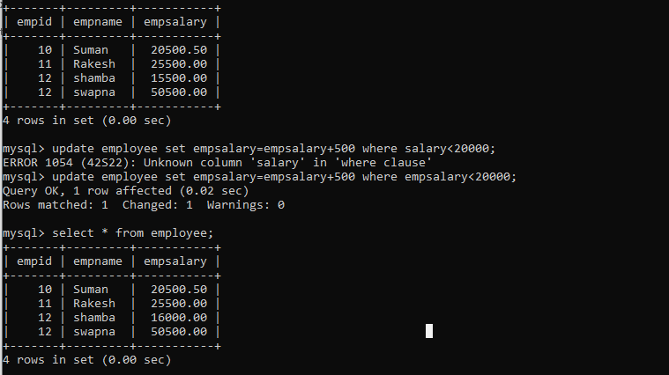

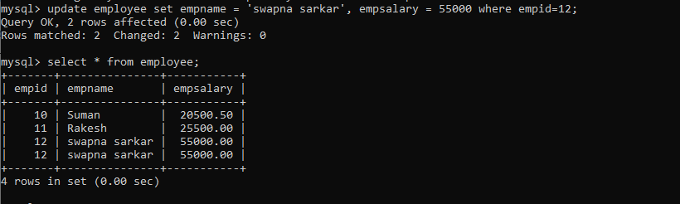

Delete all data from table(it’s not delete the table)

>> delete from <tablename>; ----it used to delete the all data from table.

We can also delete few column conditionally of a table.

>> delete from <tablename> where condition;

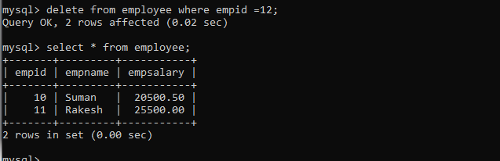

Select command:

1. All columns all rows.
2. Selected columns all rows.
3. All columns selected rows.
4. Selected columns selected rows.

All columns all rows:

Select \* from <table name>;

Selected columns all rows:

>>select <column name > from <table name>;

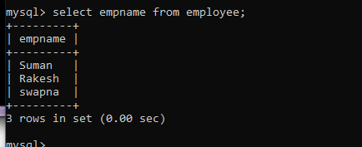

All columns selected rows:

Select \* fom <table name> where <condition>;

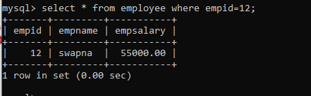

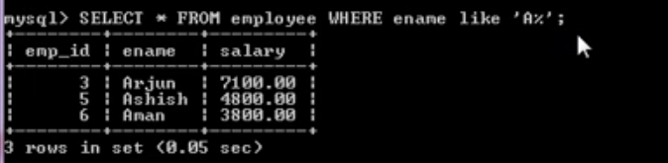

Selected columns selected rows:

>>select <column name > from <table name> where <condition>;

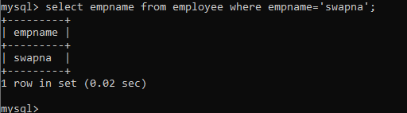

Constraint: -

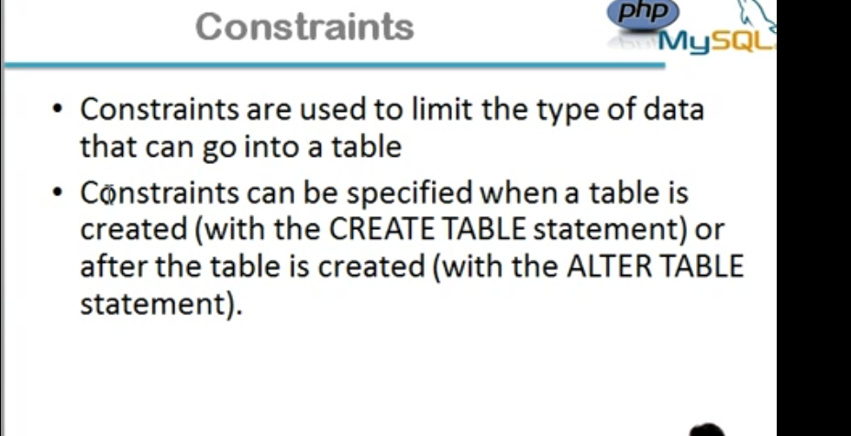

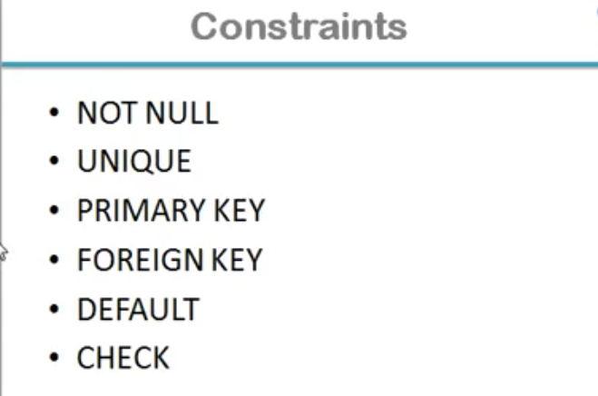

Not Null

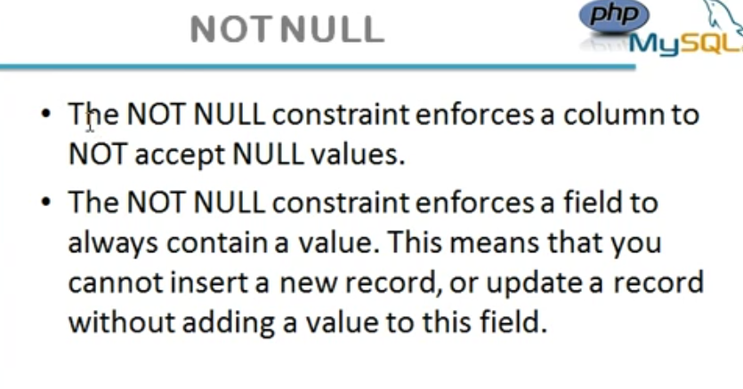

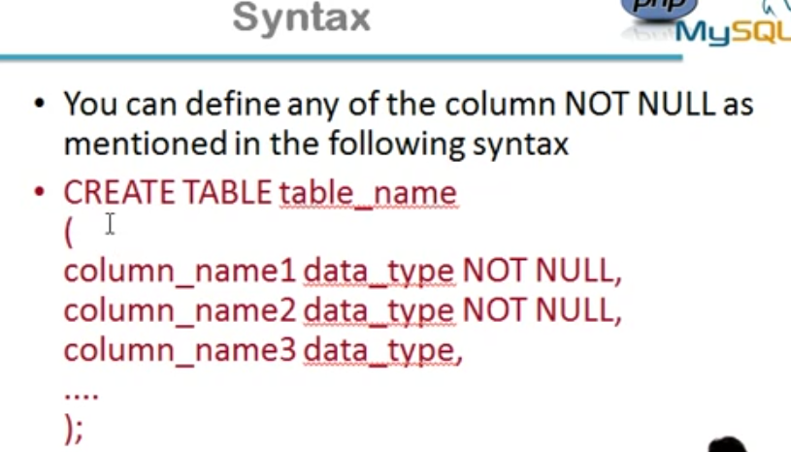

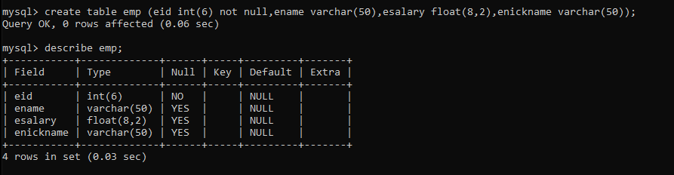

Remove not null constraint from a table

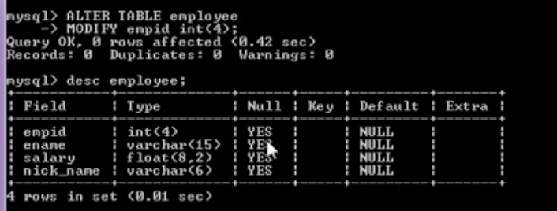

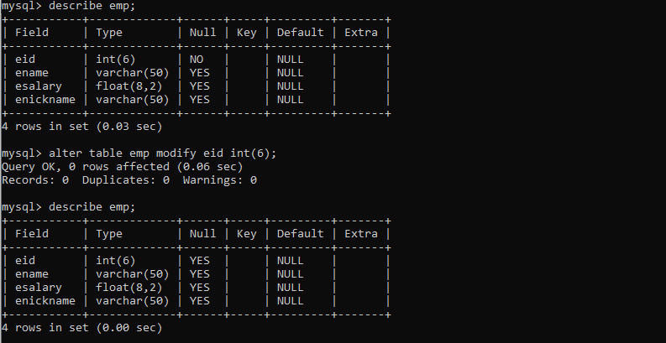

Unique constraint

